**ARTIFICIAL INTELLIGENCE**

**AIM:**

To perform dashboard analytics (Artificial Intelligence) in Sales force Lightning Experience.

**PROCEDURE:**

**STEP-1:** Login to Sales force developer account.

**STEP-2:** Setup ->App Launcher ->Service App.

**STEP-3:** Then, choose Dashboard Tab->Click New Dashboard button.

**STEP-4:** Give a new name, description and choose the destination folder

location for your dashboard to save.

**STEP-5:** Select Component button.

• Each component will show your report data in a different visual chart display.

• Then select your appropriate report to perform dashboard analytics by choosing

either standard object or custom object.

• Once you selected the report category, then apply Filters and specify conditions

according to your scenario.

• It will take a moment for the dashboard component to generate the chart.

• Your dashboard component will show your data.

**OUTPUT:**

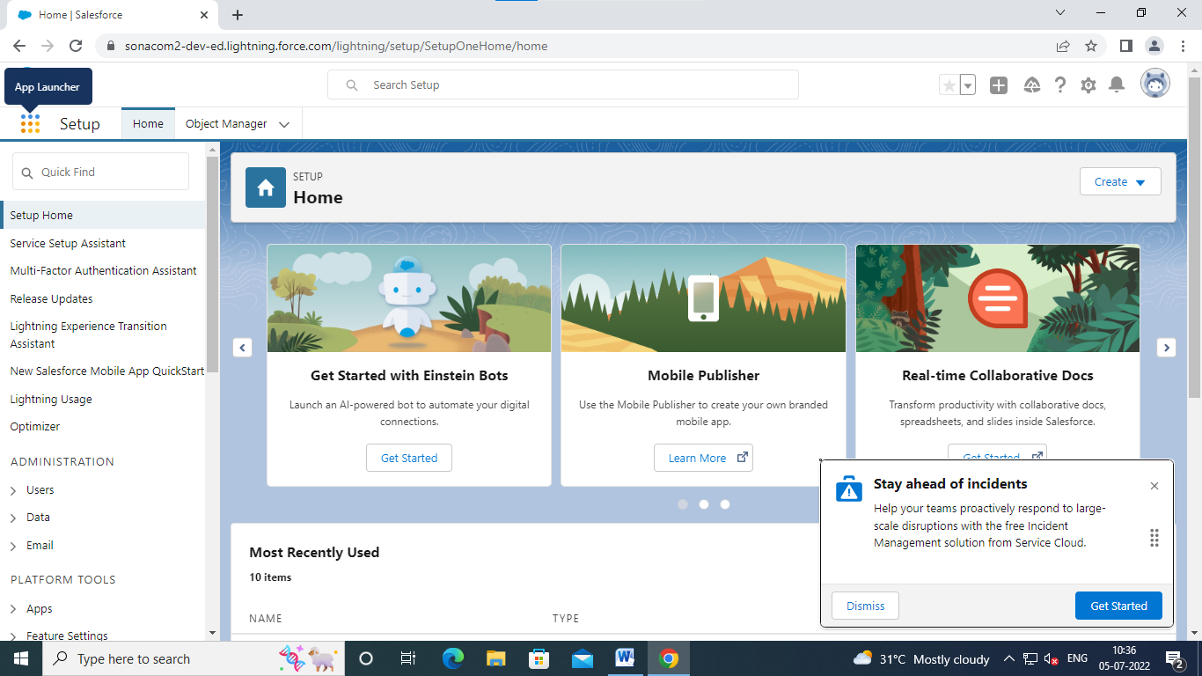

GOTO APP LAUNCHER

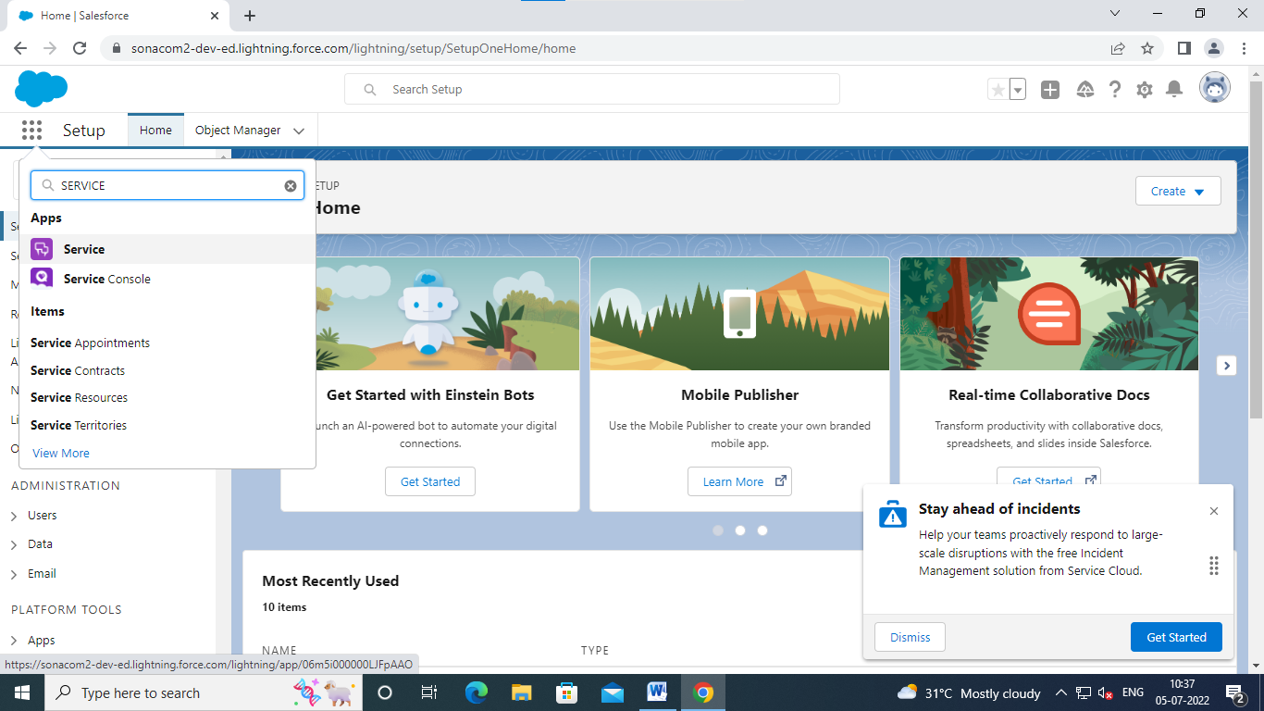

CLICK SERVICE

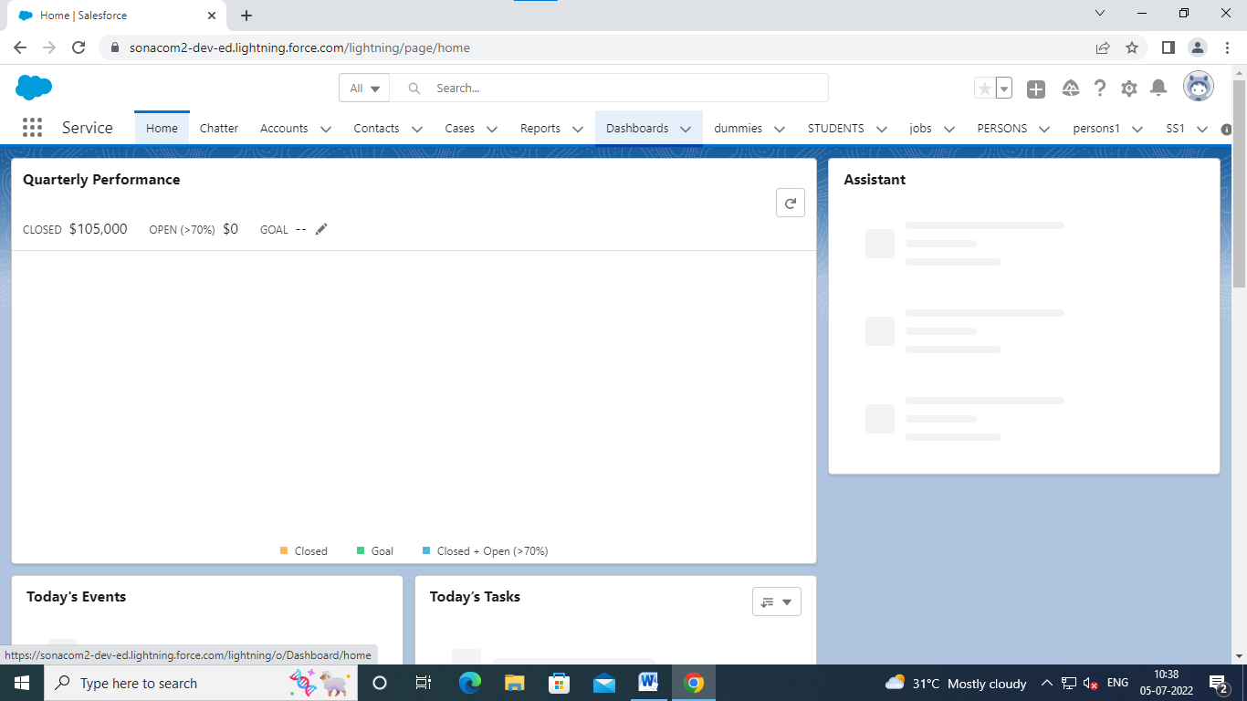

CLICK DASHBOARD

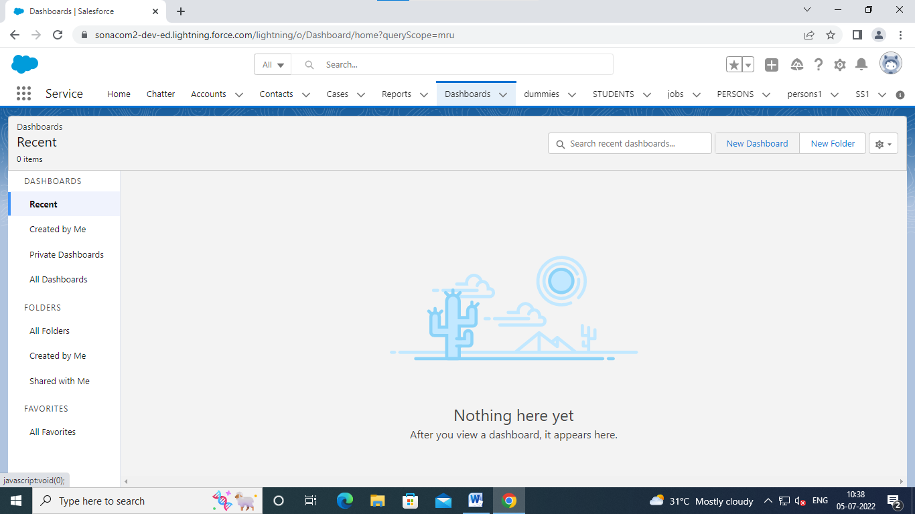

CLICK NEW DASHBOARD

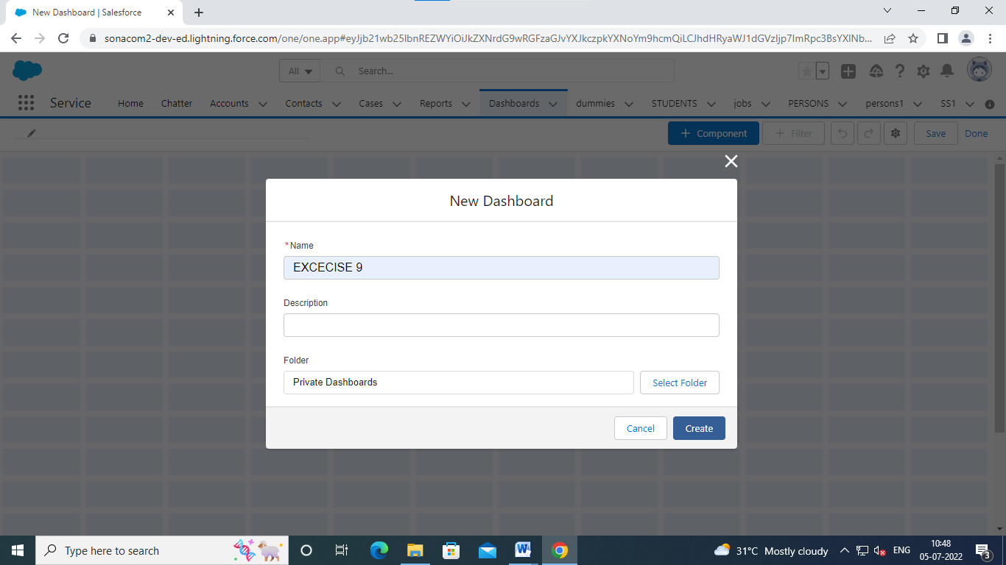

CLICK CREATE

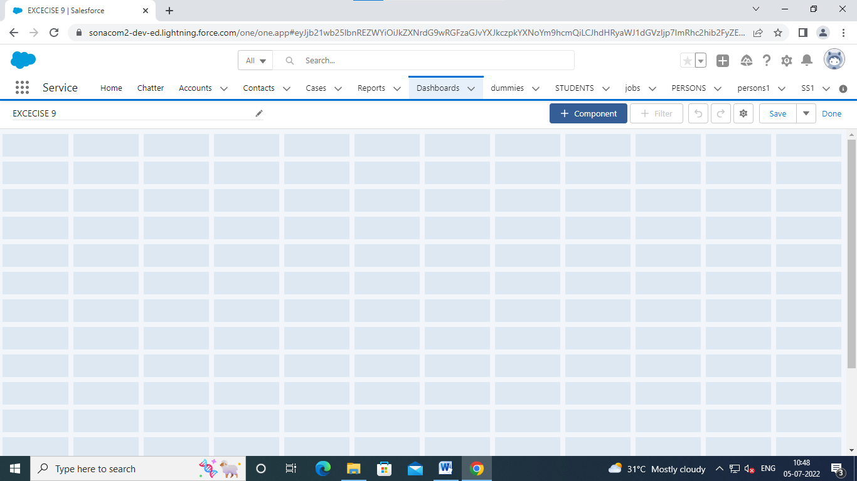

CLICK COMPONENTS

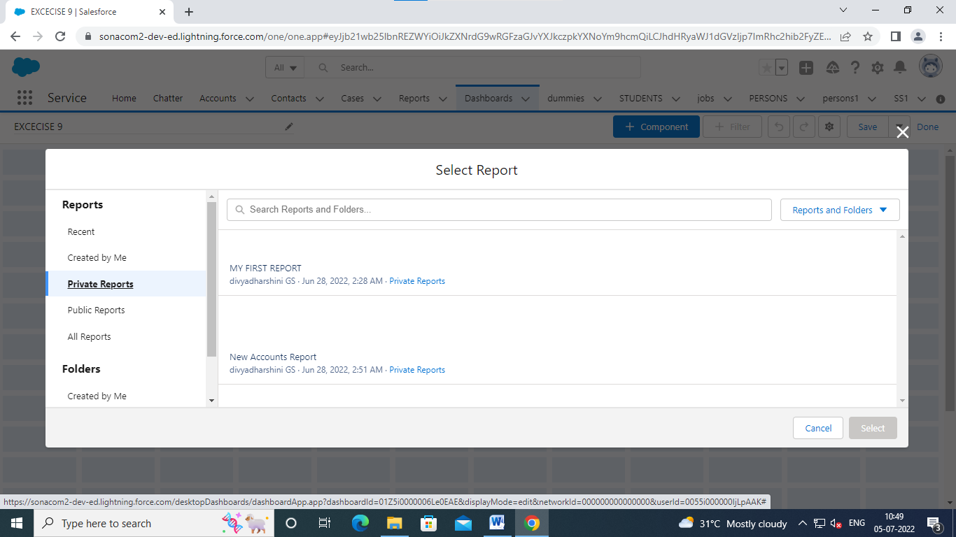

CHOOSE PRIVATE REPORTS

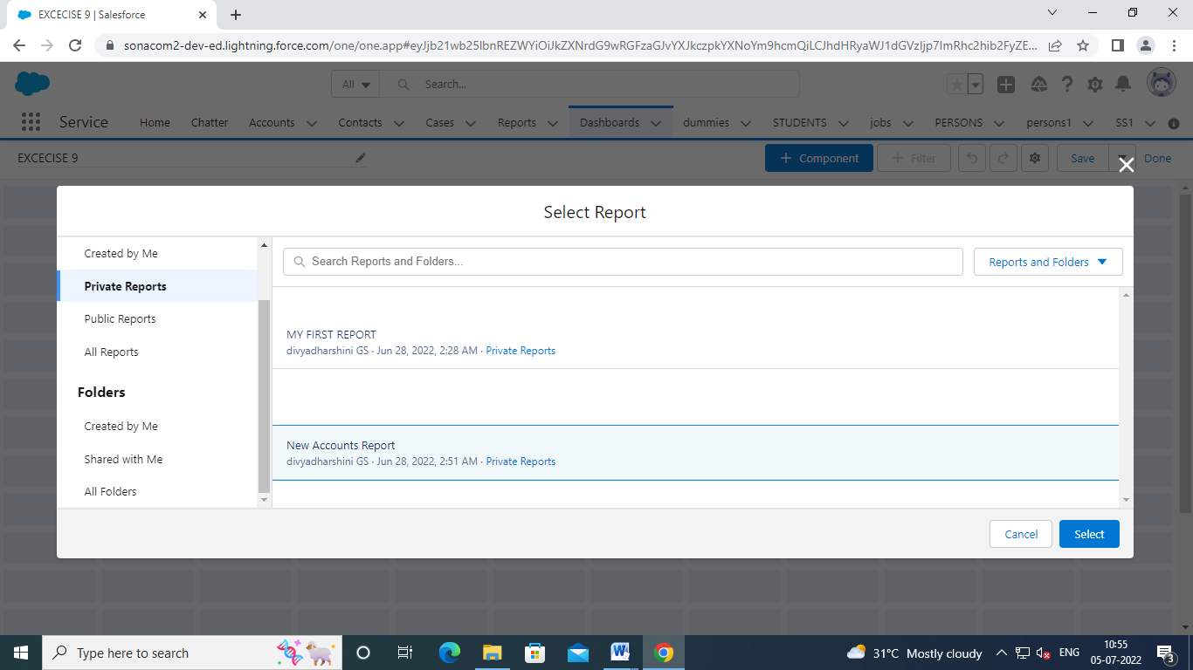

CLICK ANY ONE REPORT

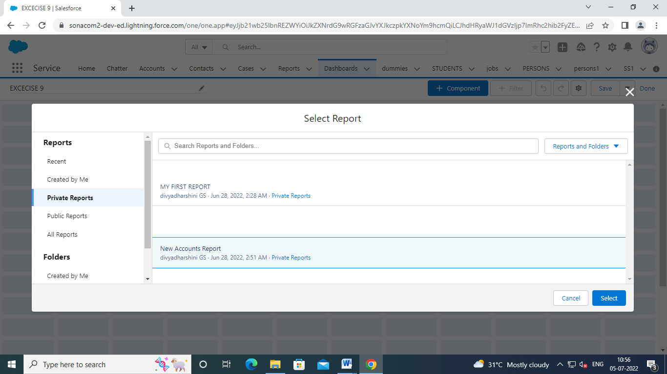

CLICK SELECT

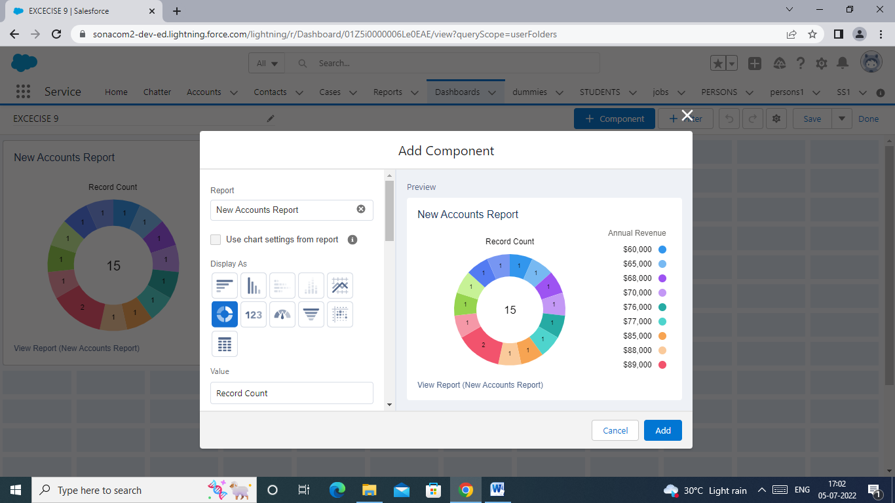

SELECT ANY ONE CHART THAT WANT TO DISPLAY

CLICK ADD

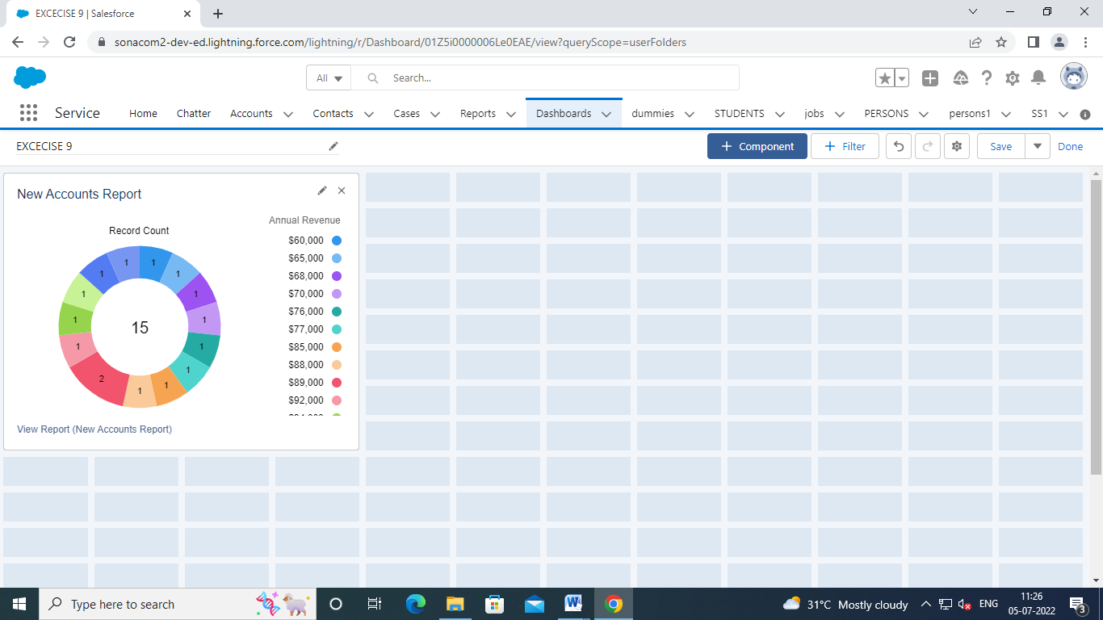

CLICK SAVE

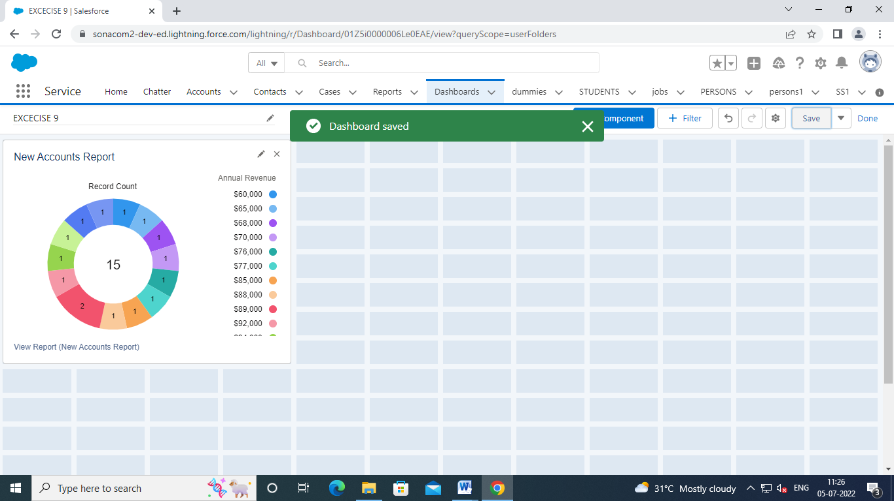

CLICK DONE

